Student’s name | …………………………………………………….…… | Grade | 1
Subject | Computer | Quiz No. | 1
Quiz No. ( 1 ) (Answer)

10

write the correct name of each part

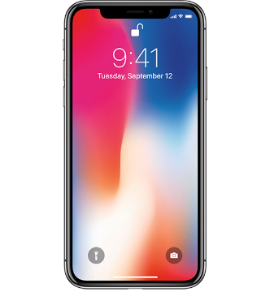
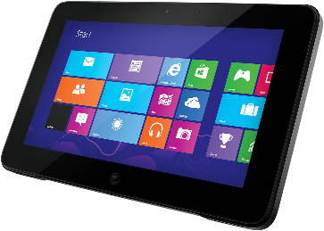
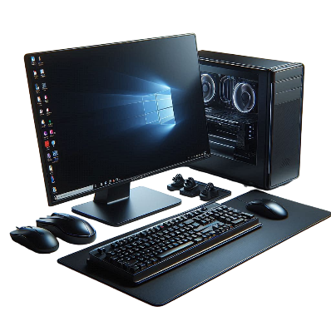

Good Luck

Laptop
Tablet
Computer
Phone
Computer
Vector
Phone
Tablet
Laptop

